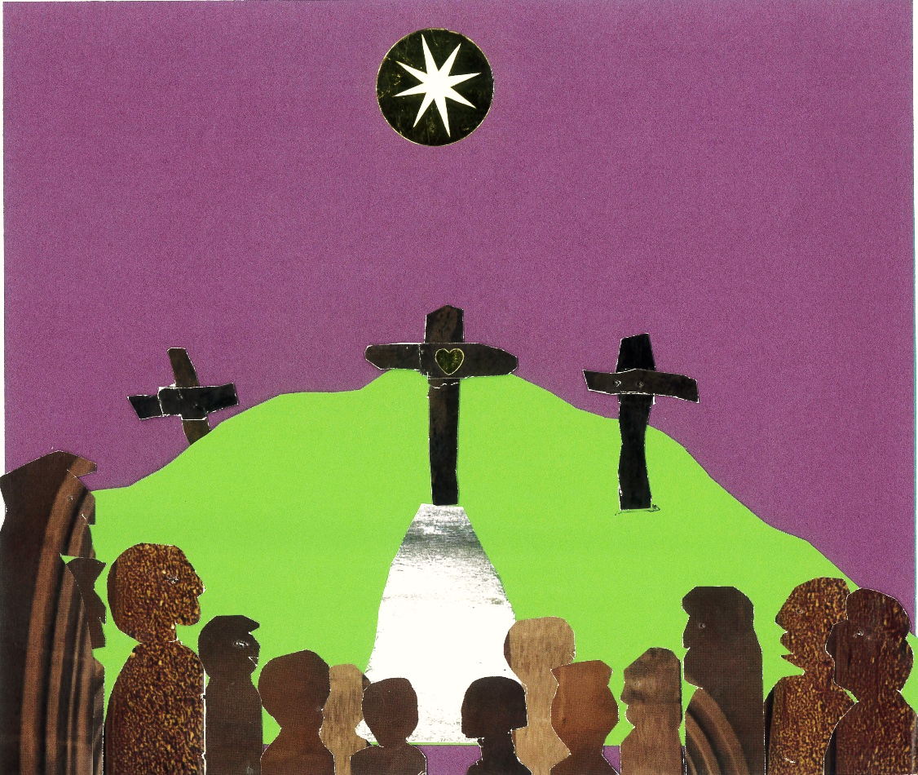

The Crucifixion
by
Sir John Stainer 1840-1901

Sunday 22nd March at 6.00pm
St Andrew’s Church Hagbourne

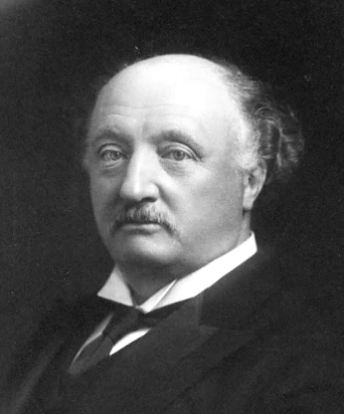

Stainer was born in 1840 in Victorian London, the 8th of 9 children. With a musical father, he took to music and became a Chorister at St Paul’s at age 7. He sung in the first English performance of Bach's St Matthew Passion.

Aged 20 he became organist at Magdalen College, Oxford. He rejuvenated the choir there with exciting new music, including the lovely "I Saw the Lord". He was an outstanding organ player and was soon appointed as University Organist, playing for the University Church. In 1872, aged 32, and now married to Eliza with 5 children, he returned to St Paul’s as organist, greatly enlarging the repertoire.

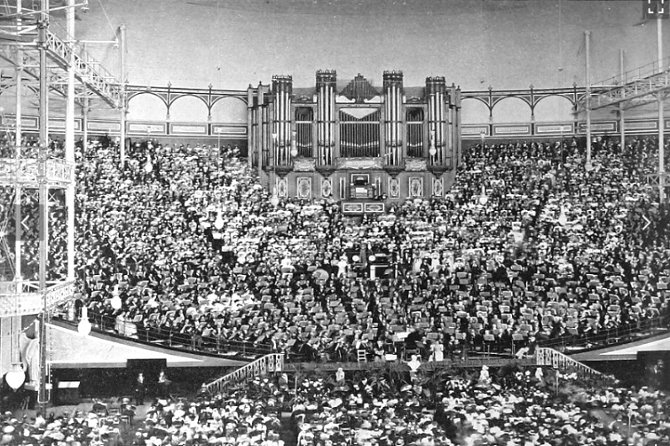

He was heavily involved in our nation's golden age of singing. Concerts with 4,000 singers were held at the Crystal Palace with Stainer at the 4,000 pipe great organ.
Stainer's Crucifixion was first performed on 24 February 1887 at St Marylebone Parish Church. They continue to sing it every year! Easier to sing than Bach's passions, it was designed to be sung by parish church choirs. The text by W Sparrow Simpson, the son of the St Paul's Precentor, is based on the King James bible with some additions.

Later his eyesight deteriorated and he returned to Oxford as Professor of Music.
It was on holiday at Verona that he died of a heart attack at 60.

Our Narrator, Jonathan Windsor was a Chorister at Magdalen College long ago, and now sings with the Lichfield Cathedral Chamber Choir.

His son-in-law Ed Chapman was Head Chorister at Lichfield Cathedral. He has Grade 8 Singing.

Thank you
Thanks to all our Benefice choir, especially soloists Margaret, Lesley, Ellie, Bill, Julian and Liz, disciples Jai, Javin, Santhi and Naga, soldiers Ron and Elizabeth, organist Charles, continuo Linda, conductor Peter, and Jason and Elaine at the office.
- Colin and Mo

The Crucifixion

1. And They Came to a Place Named Gethsemane (tenor and bass)
2. Jesu, Lord Jesu (tenor and bass with chorus)
3. Processional to Calvary (organ, soprano and chorus)
4. And When They Were Come (bass recitative)
5. Congregational hymn: Cross of Jesus
6. He Made Himself of No Reputation (alto)
7. King ever glorious (tenor aria)
8. And As Moses Lifted Up the Serpent (bass)
9. God So Loved the World (chorus)
10. Congregational hymn: Holy Jesus
11. Jesus Said, 'Father, Forgive Them' (tenor and chorus)
12. So Thou Liftest Thy Divine Petition (soprano and alto duet)
13. Congregational hymn: Jesus the crucified
14. And One of the Malefactors (bass and chorus)
15. Congregational hymn: I adore Thee
16. When Jesus Therefore Saw His Mother (tenor and chorus)
17. Is It Nothing to You? (bass)
18. From the throne of his cross (chorus)
19. Jesus Knowing That All Things Were Accomplished (tenor)
20. Congregational hymn: All for Jesus

HYMN - Cross of Jesus

Cross of Jesus, Cross of Sorrow,
Where the blood of Christ was shed,
Perfect man on thee was tortured,
Perfect God on thee has bled.
(Men)
Here the King of all the ages,
Throned in light ere worlds could be,
Robed in mortal flesh is dying,
Crucified by sin for me.

O mysterious condescending!
O abandonment sublime!
Very God Himself is bearing
All the sufferings of time!

Evermore for human failure
By His Passion we can plead;
God has borne all mortal anguish,
Surely He will know our need.

This – all human thought surpassing –
This is earth’s most awful hour,
God has taken mortal weakness!
God has laid aside His Power!
(Ladies)

Who shall fathom that descending?
From the rainbow-circled throne,
Down to earth’s most base profaning,
Dying desolate alone.

From the “Holy, Holy, Holy,
We adore Thee, O most High,”
Down to earth’s blaspheming voices
And the shout of “Crucify!”

Cross of Jesus, Cross of Sorrow,
Where the blood of Christ was shed,
Perfect man on thee was torture
Perfect God on thee has bled.
HYMN - Holy Jesu

Holy Jesu, by Thy Passion,
By the woes which none can share,
Borne in more than kingly fashion,
By Thy love beyond compare:
Crucified, I turn to Thee,
Son of Mary, plead for me.
(Men)
By the treachery and trial,
By the blows and sore distress,
By desertion and denial,
By Thine awful loneliness:
Crucified, I turn to Thee,
Son of Mary, plead for me.
(Ladies)
By Thy look so sweet and lowly,
While they smote Thee on the Face,
By Thy patience, calm and holy,
In the midst of keen disgrace:
Crucified, I turn to Thee,
Son of Mary, plead for me.

By the Spirit which could render
Love for hate and good for ill,
By the mercy, sweet and tender,
Poured upon Thy murderers still:
Crucified, I turn to Thee,
Son of Mary, plead for me.

HYMN - Jesus the Crucified

Jesus, the Crucified, pleads for me,
While He is nailed to the shameful tree,
Scorned and forsaken, derided and curst,
See how His enemies do their worst!
Yet, in the midst of the torture and shame,
Jesus, the Crucified, breathes my name!
Wonder of wonders, oh! how can it be?
Jesus, the Crucified, pleads for me!

Lord, I have left Thee, I have denied,
Followed the world in my selfish pride;
Lord, I have joined in the hateful cry,
Slay Him, away with Him, crucify!
Lord, I have done it, oh! ask me not how,
Woven the thorns for Thy tortured Brow;
Yet in His pity so boundless and free,
Jesus, the Crucified, pleads for me!

Though thou hast left me and wandered away,
Chosen the darkness instead of the day,
Though thou art covered with many a stain,
Though thou hast wounded me oft and again,
Though thou hast followed thy wayward will:
Yet, in my pity, I love thee still.
Wonder of wonders it ever must be!
Jesus, the Crucified, pleads for me!

Jesus is dying, in agony sore,
Jesus is suffering more and more,
Jesus is bowed with the weight of His woe,
Jesus is faint with each bitter throe.
Jesus is bearing it all in my stead,
Pity Incarnate for me has bled;
Wonder of wonders it ever must be!
Jesus, the Crucified, pleads for me!
HYMN - I adore Thee

I adore Thee, I adore Thee!
Glorious ere the world began;
Yet more wonderful Thou shinest,
Though divine, yet still divinest
In Thy dying love for me
(Ladies)

I adore Thee, I adore Thee!
Thankful at Thy feet to be;
I have heard Thy accent thrilling,
Lo! I come, for Thou art willing
Me to pardon, even me.

I adore Thee, I adore Thee!
Born of woman, yet divine;
Stained with sins I kneel before Thee
Sweetest Jesu, I implore Thee,
Make me ever only Thine

HYMN - For the love of Jesus

All for Jesus – all for Jesus, This our song shall ever be;
For we have no hope, nor Saviour,
If we have not hope in Thee
(Men)
All for Jesus – Thou wilt give us,
Strength to serve Thee, hour by hour,
None can move us from Thy presence,
While we trust Thy love and power.
(Ladies)

All for Jesus – at Thine altar,
Thou wilt give us sweet content;
There, dear Lord, we shall receive Thee
In the solemn sacrament.

All for Jesus – Thou hast loved us;
All for Jesus – Thou hast died;
All for Jesus – Thou art with us;
All for Jesus Crucified.

All for Jesus – all for Jesus, This the Church’s song must be,
Till, at last, her sons are gathered
One in love, and one in Thee.

